**UNIT II**

**Software Test Automation:** Fundamentals of Test Automation, Design and Architecture for Automation, Robotic Process Automation: An Introduction, Challenges in Automation

Introduction to Selenium, Components of Selenium, Advantages and Disadvantages of Selenium, Installation of Selenium IDE & Firebug Add – on, Writing the Test Cases, Selenium Commands, Assert, Verify, Locators, Enhancements, Variables, Echo, Alert and Popup.

**Software Test Automation:** Developing software to test the software is called test automation.

Test automation can help address several problems

1. Automation saves time as software can execute test cases faster than humans do
2. Test automation can free the test engineers from mundane tasks and make them focus on more creative tasks
3. Automated tests can be more reliable
4. Automation helps in immediate testing
5. Automation can protect an organization against attrition of test engineers
6. Test automation opens up opportunities for better utilization of global resources
7. Certain types of testing cannot be executed without automation
8. Automation means end - to – end, not test execution alone

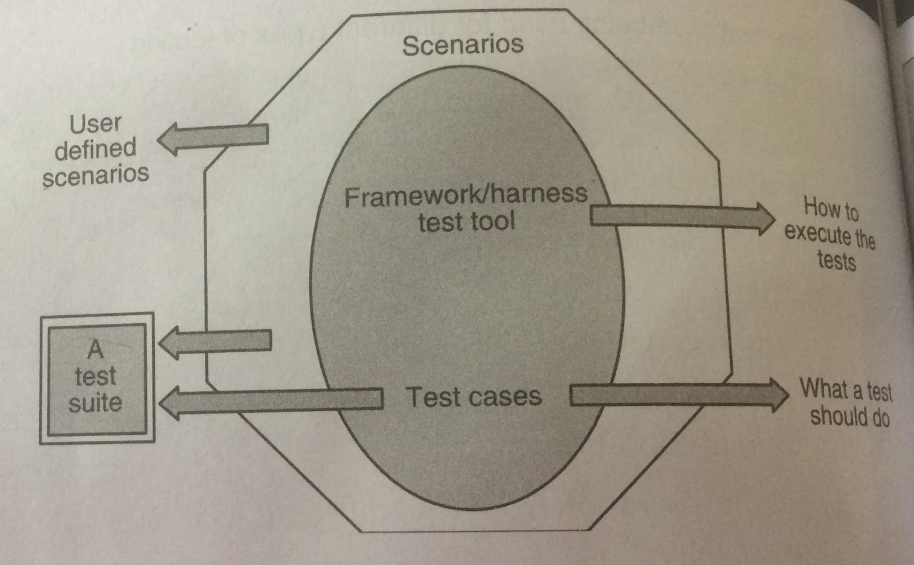

**Framework for Test Automation**

**Design and Architecture for Automation**

**Components of Test Automation: -**

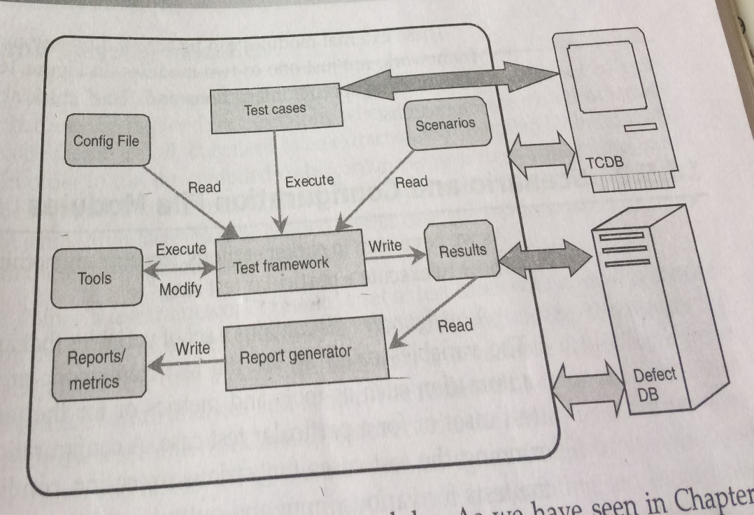

**Robotic Process Automation: The Next Transformation Lever for Shared Services**

Robotic process automation (RPA) is the application of technology that allows employees in a company to configure computer software or a “robot” to capture and interpret existing applications for processing a transaction, manipulating data, triggering responses and communicating with other digital systems.

Any company that uses labor on a large scale for general knowledge process work, where people are performing high-volume, highly transactional process functions, will boost their capabilities and save money and time with robotic process automation software.

Robotic Process Automation is the technology that allows anyone today to configure computer software, or a “robot” to emulate and integrate the actions of a human interacting within digital systems to execute a business process. RPA robots utilize the user interface to capture data and manipulate applications just like humans do. They interpret, trigger responses and communicate with other systems in order to perform on a vast variety of repetitive tasks. Only substantially better: an RPA software robot never sleeps, makes zero mistakes and costs a lot less than an employee.

**How is RPA different from other enterprise automation tools?**

In contrast to other, traditional IT solutions, RPA allows organizations to automate at a fraction of the cost and time previously encountered. RPA is also non-intrusive in nature and leverages the existing infrastructure without causing disruption to underlying systems, which would be difficult and costly to replace. With RPA, cost efficiency and compliance are no longer an operating cost but a byproduct of the automation.

* Fast benefit realization
* Minimal upfront investment
* No disruption to underlying systems
* Led by the business, with support from IT
* Highly scalable, adapts to changing business environment

**How does Robotic Process Automation work?**

RPA robots are capable of mimicking many–if not most–human user actions. They log into applications, move files and folders, copy and paste data, fill in forms, extract structured and semi-structured data from documents, scrape browsers, and more.

1. Log into any application
2. Connect to system APIs
3. Copy and paste data
4. Move files and folders
5. Extract and process structured and semi structured content from documents, PDFs, emails and forms
6. Read and write to databases
7. Opens emails and attachments
8. Scrape data from the web
9. Make calculations

**RPA Life Cycle**

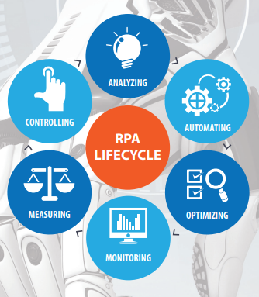

**What processes are relevant to RPA?**

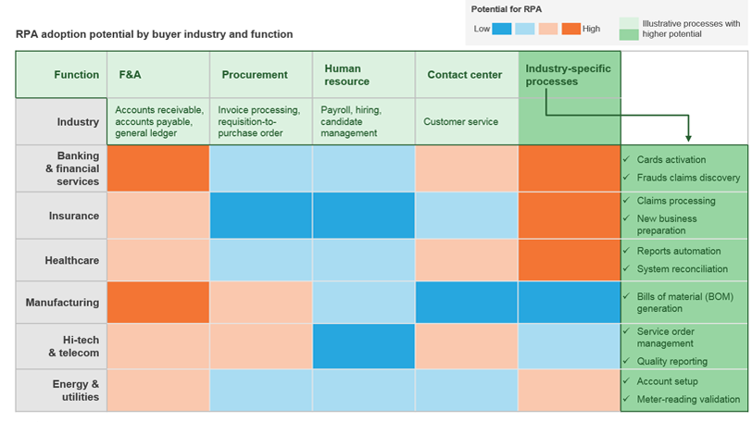

**What are the business benefits of RPA?**

Robots are here to stay. The faster you harvest their potential, the faster you create a competitive edge for your business. Robotic Process Automation delivers direct profitability while improving accuracy across organizations and industries. Enabling RPA to handle any processes will not only transform and streamline your organization’s workflow. It will allow for superior scalability and flexibility within the enterprise, doubled by fast, tailored response to specific needs. Software robots are easy to train and they integrate seamlessly into any system. Multiply them, and instantly deploy more as you go. They constantly report on their progress so you can go even bigger and better by using operational and business predictability, while improving strategically.

* Better accuracy: - Robotic Process Automation software robots are programmed to follow rules. They never get tired and never make mistakes. They are compliant and consistent.
* Improved compliance: - Once instructed, RPA robots execute reliably, reducing risk. Everything they do is monitored. You have the full control to operate in accordance with existing regulations and standards.
* Fast cost savings: -RPA can reduce processing costs by up to 80%. In less than 12 months, most enterprises already have a positive return on investment, and potential further accumulative cost reductions can reach 20% in time.
* Super scalable: - Across business units and geographies, RPA performs a massive amount of operations in parallel, from desktop to cloud environments. Additional robots can be deployed quickly with minimal costs, according to work flux and seasonality.
* Increased speed and productivity: - Employees are the first to appreciate the benefits of RPA as it removes non-value-add activities and relieves them from the rising pressure of work.

**Difference between RPA and AI**

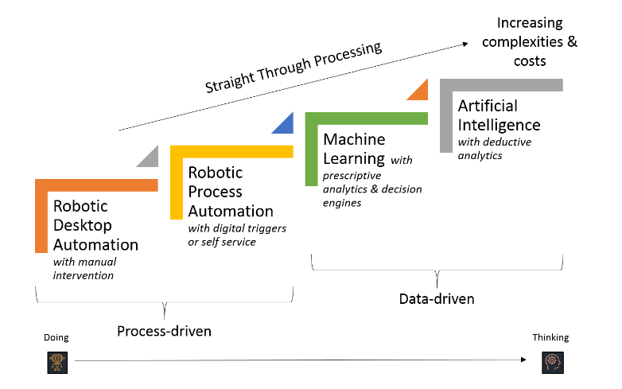

**Use Cases of RPA:**

